Chat App

Shubham Bajaj

Email: [shubhambajaj204@gmail.com](mailto:shubhambajaj204@gmail.com)

**Abstract:**

* Chatting, image, audio and video sharing is possible between two or more people using mobile phones which is common now- a-days. This system enables user to send or receive messages and images with mobile phone and personal computer.
* This system involves two users where user can send messages, share images using their devices. Both the users must have this application to be installed in their devices in order to use the functionality of this system. For security purpose, system will encrypt and decrypt the images. So, images are sent securely through network medium. This system enables the user to send messages from his mobile phone to the user using his personal computer. This system also enables the user to send and receive messages between two handheld devices i.e. mobile phones. This system requires good network connection.
* There is also group chatting involved in its which users can form group and set name according to them and communicate with multiple users simultaneously
* You can also set or update your status in app so other people can know your current status

**Proposed Work**

* Chat app with facility of secured login, personal chat to saved contact, group chat to selected members
* Featuring of setting up profile photo and status which will be visible to your contacts

**Modules:**

**Moudle1 Login/Sing up:**

* User can either signup through email or phone
* For email you need email and password
* For mobile you need phone number where you will receive OTP you can enter into app by typing OTP if you are same mobile number from where you are using app it will automatically login.
* Once you have created account or you already have account you can enter email and password and can be easily login

**Module2 Group Chat:**

* Anyone can create and set group name
* Group member can send message and user how is in group can see message and reply to them at same place
* Group can have more than 250 members.

**Module2 Personal Chat:**

* Here person can chat to another person and their message will be saved to Firebase node
* User can see saved name as of contact with their profile picture
* User can see their last seen and weather they are online or not
* Personal chat is differed by color, sender messages will be in light green color where receiver messages will be in white color

**Module3 Contacts:**

* Contacts fragment will show all those contacts which have downloaded this app and already login into app
* User can search of their friend by clicking find friend button from menu
* User have to send request to friend in order to have personal chat
* Request is handled by different module called Request module

**Moudle4 Request:**

* User can see all the request received
* User can either accept or decline request accordingly
* User will be able to see name, status, image of friend request
* After accepting request particular contact will be added to Contact fragment so both users can exchange message now.

**Module5 Menu:**

* Menu module have different menus such as find people, create group, settings logout.
* Find people will show you all the users from where you can select your knowing and send request to them
* Create group will show you dialog box where you can write group name and create group
* Setting can be used to change your username, status, profile image.
* Logout will take you out of app and will ask for login or signup

**Results:**

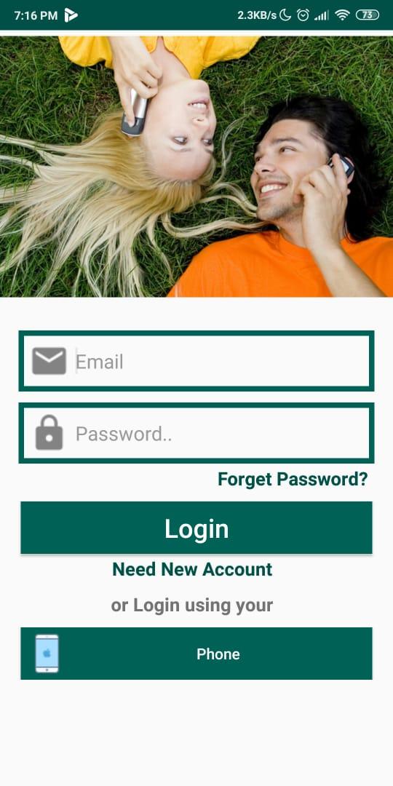 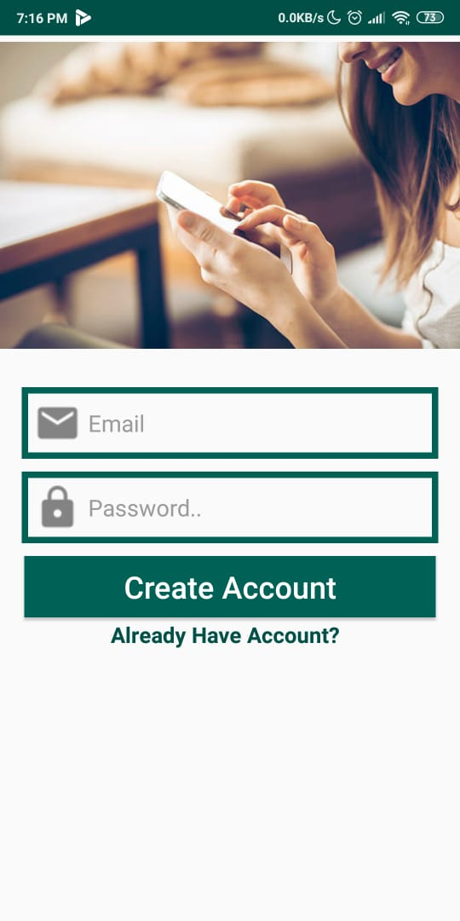

**Signup**

**Login**

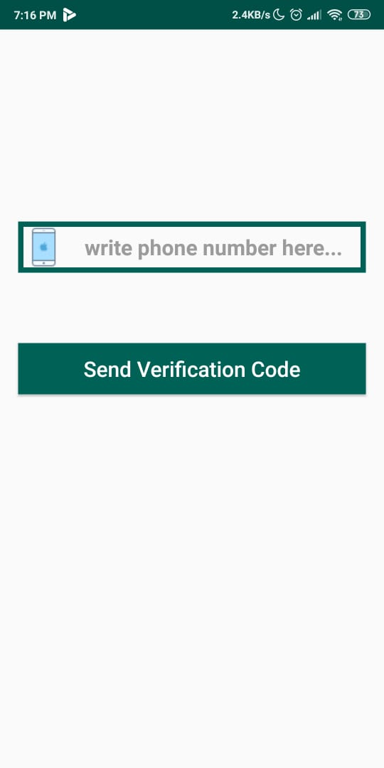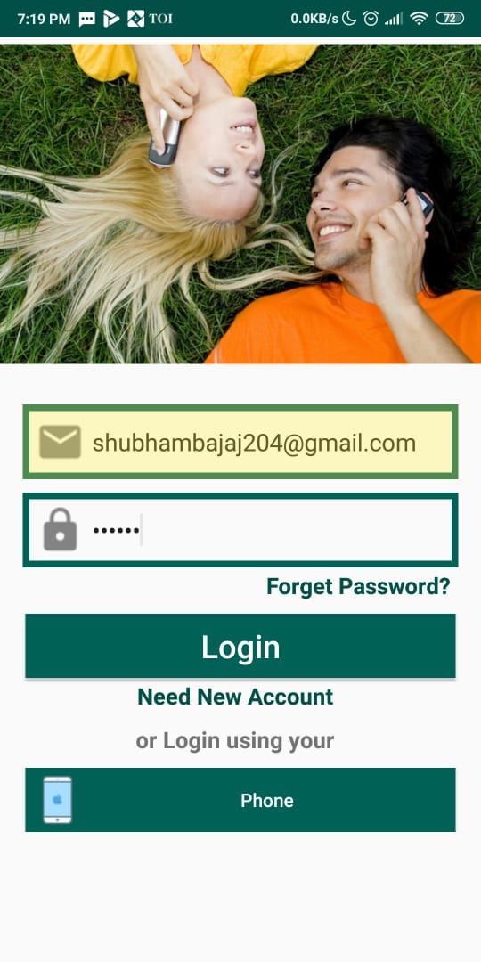

Or

**Different Modules**

